**Chapter III – Editing and Debugging SAS Programs**

1. **Open a program using**:

* Coding:

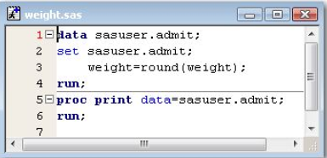

* File Shortcuts (Open a program):

double click File Shortcuts (SAS Explorer) - File (double-click / right click and select Open)

* My Favorite Folders (view and manage any files in your operating environment):

View – My Favorite Folders – File (double-click / right click and select Open)

* Open Window

Open – select file

* Issuing an INCLUDE Command

Open a program

**INCLUDE** *'file-specification'*

*file-specification* is the physical name by which the host system recognizes the file

Eg: *INCUDE 'd:\programs\sas\myprog1.sas'*

1. 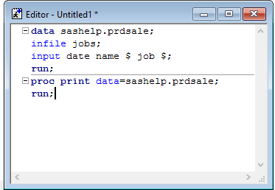**Editing SAS program**

* **Enhanced Editor**

* **Using Abbreviations** (define a character string so that when you type it and then press the Tab key or the Enter key, the string expands to a longer character string):

Eg: abbreviation: “myv7sasfiles” can be expanded to ‘c:\winnt\profiles\myid\personal\mysasfiles\v7’;

* Create abbreviation:

Tool – Add Abbreviation – For abbreviation, type the name of the abbreviation – For Text to insert for abbreviation, type the text that the abbreviation will expend intp – OK

* **Multiple views of a file**: different part of the same file
* **Number Line**:
* Turn on NL: use NUMS command: type NUMS on the command line or in the command box – Enter

Permanently display NL: Tools – Options – Program Editor

* Turn off NL: type again.
* **Text Editor Line Commands** (Enable you to delete, insert, move, copy, and replace text)

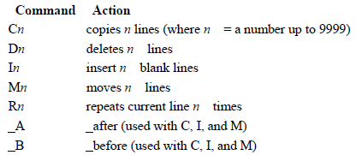

 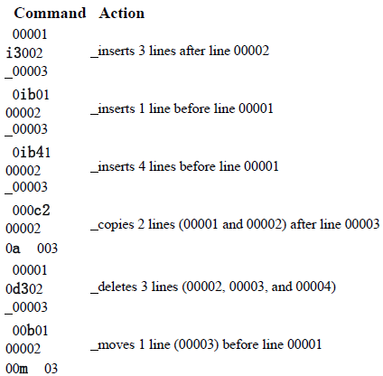

Eg: Insert a 2 lines after the first RUN

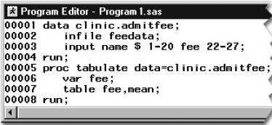Type i2 in the line number area of line #00004, two blank lines are created after the RUN

* 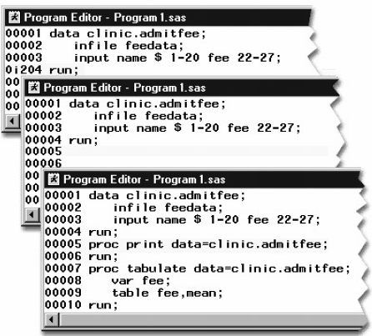**Block Text Editor Line Commands** (specify the command on the first line affected and on the final line affected, and then press Enter.)

Enable you to delete, insert, move, copy, and replace multiple lines in the program editor window

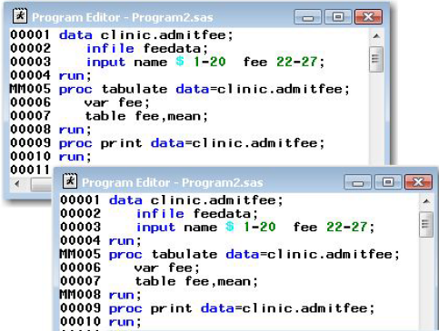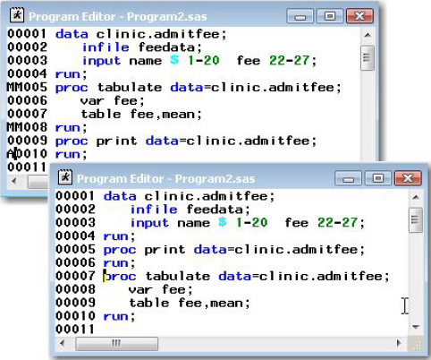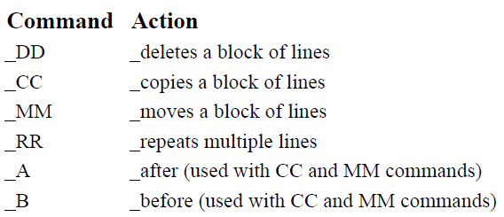

* **Recalling SAS Program**
  + - * + Recall a program to the Program Editor by selecting Run - Recall Last Submit
        + Submitted SAS code is stored in the recall buffer (accumulate each time you submit a program)
        + if you submit two programs, you will need to select **Run**→**Recall Last Submit** two times to recall the first program
* **Saving SAS Program**
* File – Save as
* Using FILE code:

Eg:　Want to save file in this position D:\Programs\Sas\Newprog.Sas

*FILE 'd:\programs\sas\newprog.sas'*

* **Clearing & Undo SAS Program Window** (clear the Output window, Editor window, Program Editor window, or Log window)
* Edit – Clear All
* Edit – Undo
* **Interpreting Error Massage**
* Error Type

1. Syntax error (语法错误)
2. Data error (实际data未在SAS程序中specify)
3. 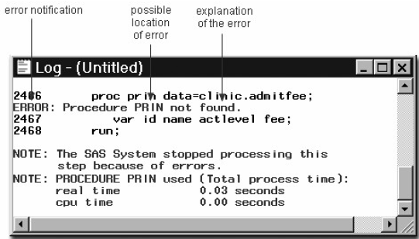**Syntax Error**

When syntax error take place, log window will display the word ERROR, identifies the location, and give explanation

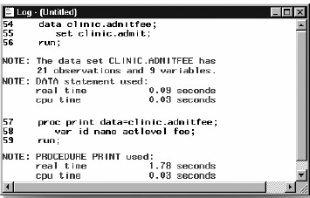 Eg: Correct program:

* **Common problems**
* Omitting semicolons or RUN statement
* Unbalanced quotation mark
* Specifying invalid options
  + **Add a RUN at end of each step**

Because there is nothing to indicate the end of the PROC step, the PRINT procedure waits before executing, and a “PROC PRINT running” message appears at the top of the active window.

* + **Resolving “Unbalanced Quotation Marks” in the Windows Operating Environment**

When the program is submitted, SAS is unable to resolve the DATA step, and a “DATA STEP running”message appears at the top of the active window.

* + **Invalid Option**

An invalid option error occurs when you specify an option that is not valid in a particular statement

When Error take place, a message appears in the Log window indicating that the option is not valid or not recognized

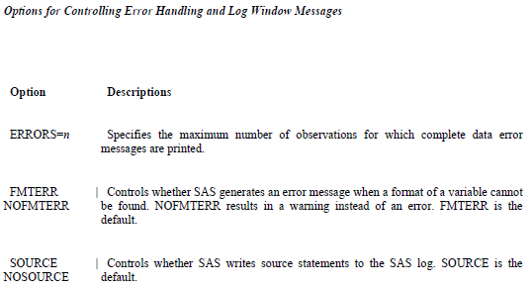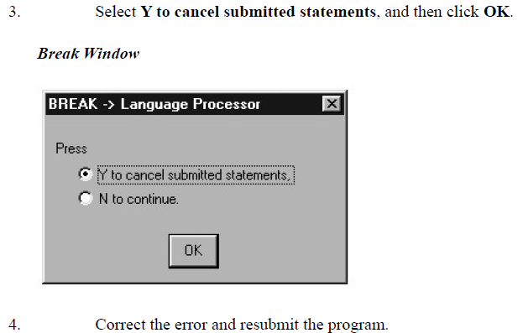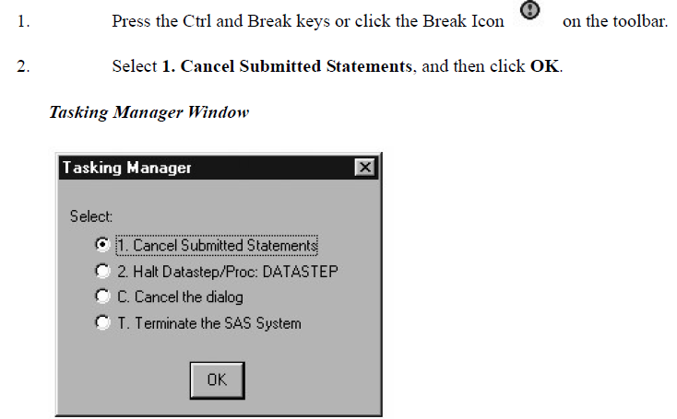

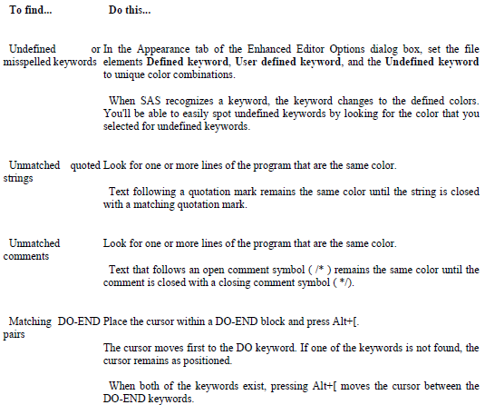

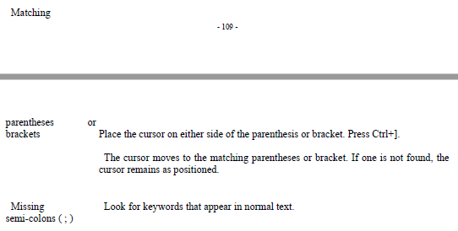

**Debug using DATA Step Debugger (Interactive)**

Determine logical error by issuing commands to execute DATA step statements one by one, and then to pause to display the resulting variables' values in a window.

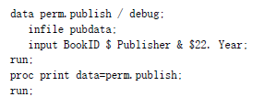Can repeat the process of issuing commands and observing results as many times as needed in a single debugging session

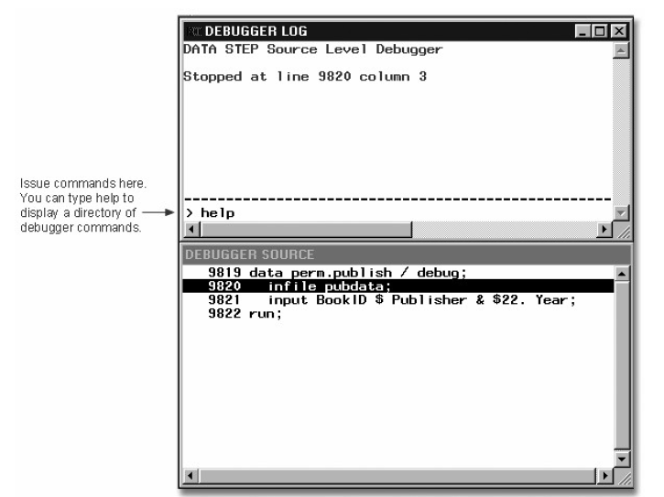

**练习**

1. Suppose you have submitted a SAS program that contains spelling errors. Which set of steps should you perform, in the order shown, to revise and resubmit the program?
2. Correct the errors.

After correcting the errors, you can resubmit the revised program. However, before doing so, it's a good idea to clear the messages from the Log window so that you don't confuse the old error messages with the new messages. Remember to check the Log window again to verify that your program ran correctly.

Clear the Log window.

Resubmit the program.

Check the Log window.

1. Correct the errors.

Resubmit the program.

Check the Output window.

Check the Log window.

1. Correct the errors.

Clear the Log window.

Resubmit the program.

Check the Output window.

1. Correct the errors.

Clear the Output window.

Resubmit the program.

Check the Output window.

1. How can you tell whether you have specified an invalid option in a SAS program?
2. A log message indicates an error in a statement that seems to be valid.
3. A log message indicates that an option is not valid or not recognized.
4. The message “PROC running” or “DATA step running” appears at the top of the active window.
5. You can't tell until you view the output from the program.
6. Which of the following commands opens a file in the code editing window?
7. file 'd:\programs\sas\newprog.sas'

One way of opening a file in the code editing window is by using the INCLUDE command. Using the INCLUDE command enables you to open a single program or combine stored programs in a single window. To save a SAS program, you can use the FILE command.

1. include 'd:\programs\sas\newprog.sas'
2. open 'd:\programs\sas\newprog.sas'
3. all of the above
4. Suppose you submit a short, simple DATA step. If the active window displays the message “DATA step running” for a long time, what probably happened?

Without a RUN statement (or a following DATA or PROC step), the DATA step doesn't execute, so it continues to run. Unbalanced quotation marks can also cause the “DATA step running” message if relatively little code follows the unbalanced quotation mark. The other three problems above generate errors in the Log window.

1. You misspelled a keyword.
2. You forgot to end the DATA step with a RUN statement.
3. You specified an invalid data set option.
4. Some data values weren't appropriate for the SAS statements that you specified.